**Lab 08 – Nuts and Bolts**

Open BlueJ, and create a new BlueJ project titled **Lab08-NutsAndBolts** in your CS\LABS folder (H:\CS\LABS).

Create a new class with this code skeleton:

//Name:

import java.util.*;

public class PracticeProblems

{

public static void main(String[] args)

{

Scanner console = new Scanner(System.in);

}

}

REMEMBER – if statements are used for *conditional code execution.* Much more information can be found in the powerpoint notes; here is an example of basic if statement syntax:

int a = 12;

if (a > 10)

{

System.out.prinltn("Must be over 10!");

}

**Would print:** Must be over 10!

**Before each problem, insert a COMMENT with the problem number.**

1. Declare an integer variable called apples and set it equal to a value taken from the keyboard. Write an if statement that will print That’s positive! if the value of applesis positive.
2. Get a new value for apples from the keyboard and write an if statement that will print Omg. It’s positive AND even! if the value of apples is both positive and even.

//HINT – the modulus (%) operator will be useful here

1. Add an else statement to your code in the problem above that will print I don’t like that number! if applesis not even or not positive.
2. Declare a variable called votingAgeand set it equal to 18. Next, declare a variable called actualAge and get a value from the keyboard (user). Write the code to print You can vote if actualAge is greater than or equal to votingAge, and You can’t vote otherwise.
3. Read three integers from the keyboard, angle1, angle2, andangle3, that represent the angles of a triangle*.* Write the code (using if statements) to print the **type** of the corresponding triangle (isosceles, equilateral or scalene). For example, with 60, 70, and 50, you would print That’s a scalene triangle. Print Error if the angles don’t add up to 180.

To help with this problem, complete the table below:

| List several examples of different angle measurements that should result in an output of:  ISOSCELES | List (the only) example of angle measurements that should result in an output of:  EQUILATERAL | List several examples of different angle measurements that should result in an output of:  SCALENE | List several examples of different angle measurements that should result in an output of:  ERROR |
| --- | --- | --- | --- |
|  |  |  |  |
| What do these all have in common? | What is special about this unique set? | What do these all have in common? | What do these all have in common? |
|  |  |  |  |
| What types of input values might look like an ISOSCELES triangle, but actually aren’t? | What types of input values might look like an EQUILATERAL triangle, but actually aren’t? | What types of input values might look like an ISOSCELES triangle, but actually aren’t? |  |
|  |  |  |  |

1. Complete the ‘Worksheet – If Statement #2’ (Excel file). Make sure to save it when done.

**Nuts and Bolts app**

Create a new class with this code skeleton:

//Name:

import java.util.*;

public class NutsAndBolts

{

public static void main(String[] args)

{

Scanner console = new Scanner(System.in);

}

}

In addition to being an aspiring programmer, you run an online hardware store specializing in nuts, bolts and washers. Your store has the following items at the following prices:

* 5 cents per bolt
* 3 cents per nut
* 1 cent per washer

Write a program that **asks the user** for the number of bolts, nuts, and washers they wish to purchase and then calculates and prints out the total (save each into its own variable).

**A correct order must have:**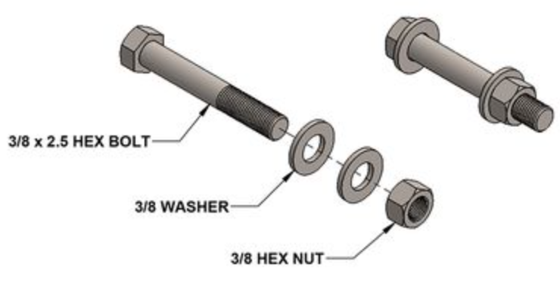

* **At least as many nuts as bolts**
* **at least twice as many washers as bolts**

If those conditions aren’t met, the order has an error. For each error, the program writes out "Check order: too few nuts" or "Check order: too few washers" (as appropriate). Both error messages are printed if the order has both errors. If there are no errors, the program should print "Order OK!"

***In all cases, the total price in cents (of the specified number of items) is printed.*** Below are sample runs of the program (**user input shown in red**), use them to test your code:

Number of bolts >>> **12**

Number of nuts >>> **8**

Number of washers >>> **21**

Warning! Check order: too few nuts

Warning! Check order: too few washers

Total cost (in cents) >>> 105

and another…

Number of bolts >> **32**

Number of nuts >>> **32**

Number of washers >>> **356**

Order OK!

Total cost (in cents) >>> 612